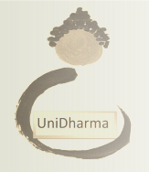
Associazione Unidharma
www.unidharma.weebly.com
facebook : Associazione UniDharma
Contacts: info@unidharma.it
+ 39 3662260017
+39 347 8152565 (wechat, whatsapp)
+39 335 8244971 (whatsapp)

“CHAN RETREAT”

The Unidharma Association announces a Patriarch Chan Intensive Retreat dedicated to learning the "huatou" method.
Schedule: The retreat starts on July 14, 2017 and finish July 22, 2017, in the evening.
Location: Aisone, Località Burat 1, in Valle Stura, province of Cuneo in the Piedmont Region, Italy
Cost: € 200,00. Free of charge for ordained monks and nuns
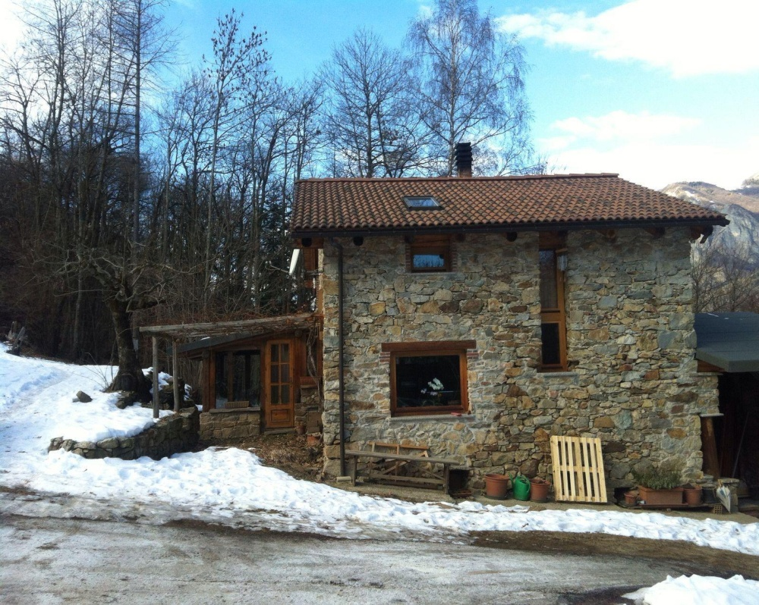
Practice
It is mandatory to take part in the entire retreat in order to study and explore the "huatou method".
This type of a retreat is divided into various practices that include seating, walking, brisk walking, exercise, work, and dharma teachings.
The instruction will be conducted by the Monk Da Xing Fa Shi in three languages — Italian, English, and Chinese — to facilitate the understanding of all participants.

Anyone wishing to attend should complete an application form and answer questions related to your previous experience with meditation and retreats.

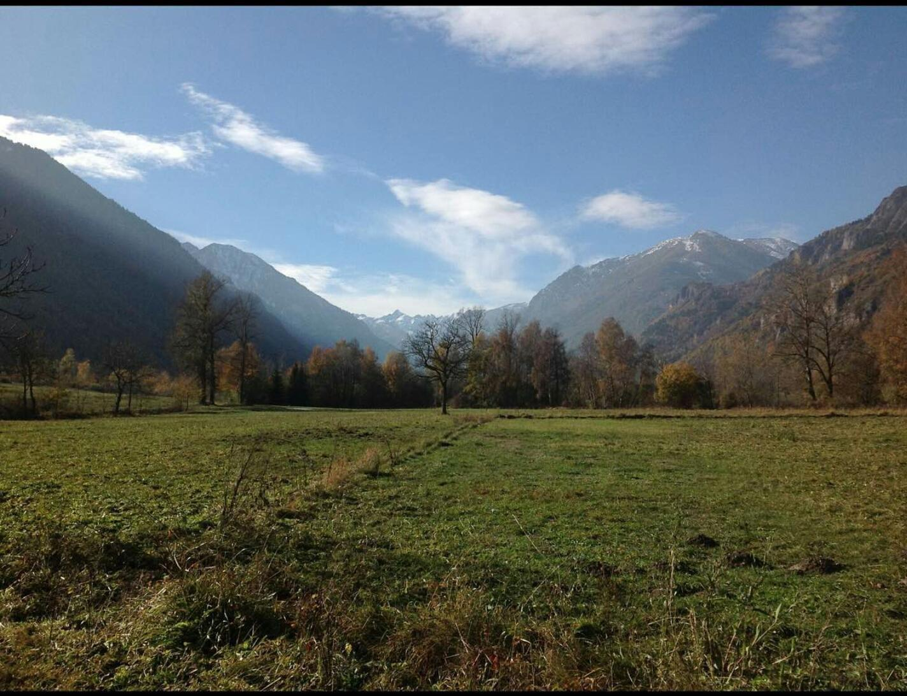

Travel Directions
To get to Aisone, it is essential to reach the city of Cuneo, railway station, from which we will bring you to the village of Aisone.
To reach the city of Cuneo, if you travel by air it is best to arrive at the airports of Turin, Genoa, or Milan. The airport of Milan is the least recommended, as it would take 4-5 hours of travel from the airport to reach Cuneo.
You should choose flights that arrive no later than 3 p.m. on July 13, as the city of Cuneo is not accessible by public transportation after 9 p. m. (If you are unable to reach Cuneo within the expected time, you may have to stay at a hotel at your own expense).
You can also get a flight that arrives before 7:00 a.m. on July 14; however, it is advisable to arrive the day before the start of the retreat. At your request we can provide detailed directions to Cuneo, such as which public transportation to use, timetables, stops, etc.
The retreat will take place in the mountains, about 850 meters above sea level, in a stone hut surrounded by woods.
Sleeping accommodations include sleeping either in the hut, equipped with your own sleeping bag, or in your own tent outside.
Meals will be vegan.
Those who have allergies should consider the possibility of adapting to the proposed meals, or forego the retreat.
Those who bring their own medications need to use own containers and be in charge of them on your own.

You should bring the following clothing:
• walking shoes and rain footgear
• Non-slip socks for indoors
• slippers
• comfortable clothes and a sweater or jacket because it's cold in the early morning
• cosmetics, personal hygiene items, and medication— but do not bring strong deodorants or perfumes
• a hat and sunglasses to protect from the sun
• a sleeping bag
- a thermos
- a flashlight for the evening.
- Please note that no laundry is available at the retreat, so please bring sufficient quantities of underwear, socks, etc. to last through the retreat

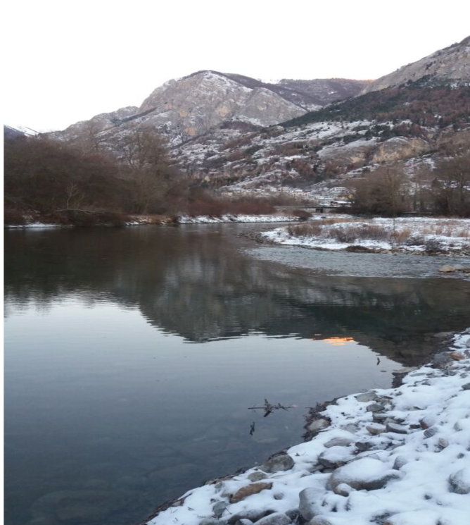

It is forbidden:
- to make use of electronic devices (tablet, mobile phones. MP3, etc.) and all kinds of reading materials.
- the use of alcohol and intoxicating or mind-altering substances.
During the duration of the retreat silence is to be observed, except during times set aside for questions.
Completed applications must be received by May 31, 2017, given the limited number of places.
N.B. The cost of the retreat includes accommodations, meals, and instruction in meditation. It does not include travel to / from airports and the use of public transportation to reach the place.
Secretary
Domenica Guglielmo

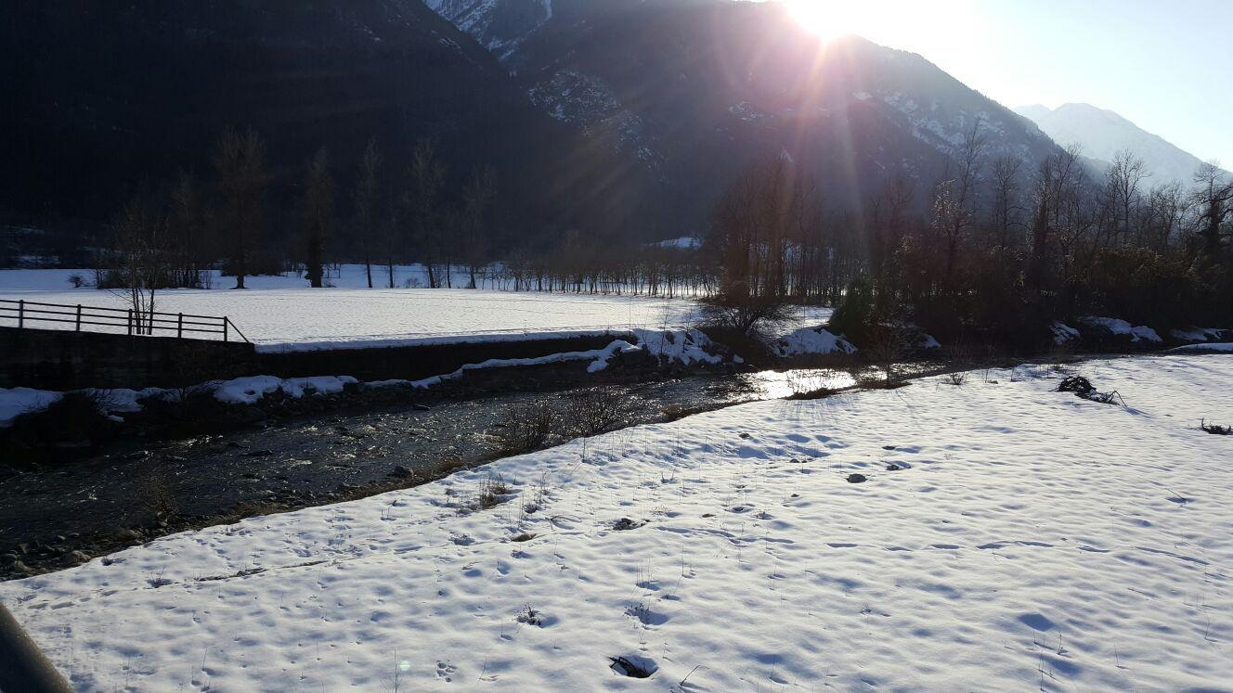
MINI-TOUR
At the end of the retreat, there will be a "mini-tour" organized by UniDharma and led by the Monk Da Xing.
Only those who have participated in the retreat are eligible for the mini-tour, which is optional (notify us by May 31 if you want to join); if you join, you must participate in the entire mini-tour.
To participate in the tour, adaptability is the essential requirement: the low cost of the mini-tour must by necessity come somewhat at the expense of comforts.
During the mini-tour we will visit several cities in North West Italy.
Overnight stays, with a sleeping bag, will be held at the UniDharma associations of Aisone and Genoa.

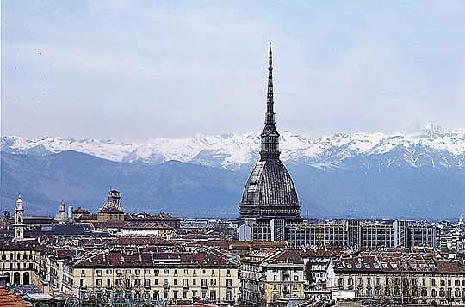

All mini-tour travel will take place by the train.
The tour will last from July 23 through the evening of July 28 and will end in Genoa. The departure from mini-tour destination of Genoa to airport should take place after July 28. So, we’ll arrive in Genoa on July 28 in the evening and people can leave the Country on July 29. Furthermore, people must attend the whole minitour. They cannot leave before.
Cost of mini-tour: € 250,00. It includes: overnight stays (modest sleeping accommodations, with a sleeping bag), meals, travel by public transportation, mostly by train. It does not include: extra meals and beverages except water, and travel to the airport.
Total cost retreat + minitour : € 450,00

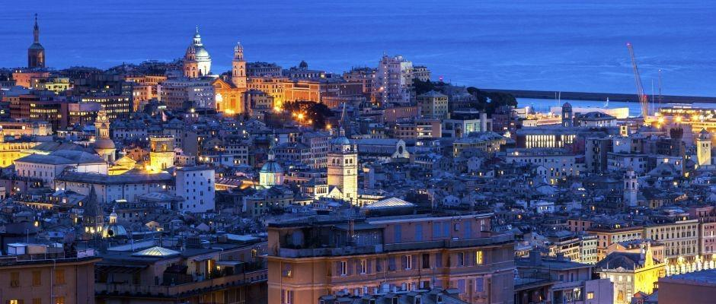

Secretary
Domenica Guglielmo

